Stoke North Big Local Trip to……..
Whitley Bay Northumberland
Attendees Jeff Walker, Ali Lias, Pam Heraty, Maggie Ferneyhough, Mark Roberts
February 16th to 19th extended by 1day

The trip started by us all piling into a metal tin with windows or as its commonly known as a minibus. So, Jeff the chauffer Pam the sat nav up front obviously then me (Ali) Maggie and Mark two wheelchair and bags in the back with lots of leg room.
With plenty of tarmac under the rubber and a few comfort breaks and a dinner break. We reached the Angel of North.
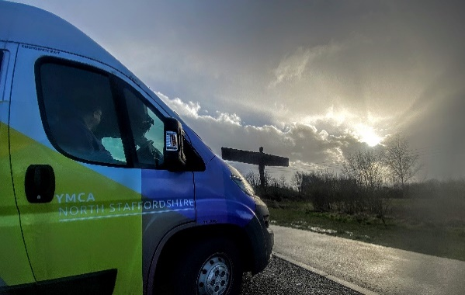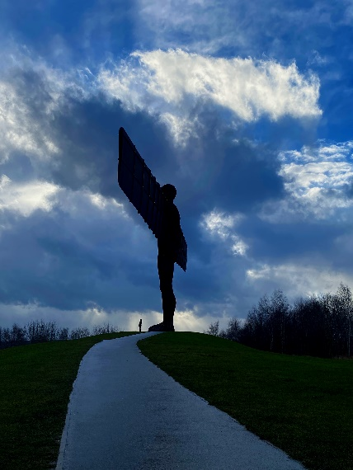
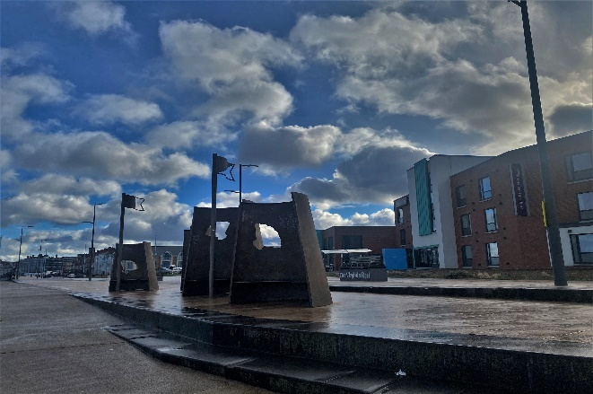
At the bottom of the picture on the right you may be able to see a figure that is Mark. After Jeff kindly stop to see this amazing art work. We drove through Newcastle and in no time, we arrived at the Hotel in Whitley Bay.

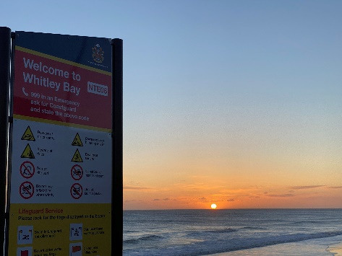
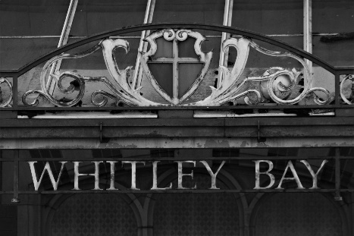
After a nice meal a good night sleep a fantastic sun rise. More Coffee we walked across the town sea front of Whitley Bay to the base of the Big Local based here. An old job centre and it was big. We had a lovely welcome, and we all got a brew and met the chairperson. She explained to us how they had another property, and they were looking at possibly buying it but luckily on there board they have a property surveyor and he told them it was not a good option, so they got this place and have the option to buy at a cheaper rate. We talked about a lot of things like charity status, social enterprise letting and other wide ranging topics. Then us and the chair and another colleague show us sone of the area the Big Local covers not big, but they have a diverse town with some wealthy pockets and the same for low waged and social housing. We then stopped for some lunch at a very nice chip shop and disgusted other issues in their area and the some of the major issues in our area things like size of area covered the new garden project and general comparison. The visit was good to see how areas like this not so similar issues have but not like how it is with us, but this was far smaller area covered than ours. I would like to thank them on how they looked after us and were very accommodating.
Then a few hours later we heard that the next storm after Enid was coming, and it was forecasting some bad weather. With risk to life bad driving condition etc. So were advised that we should stop an extra night. So that is what we did. So after a lovely stay we headed home on the Saturday morning.
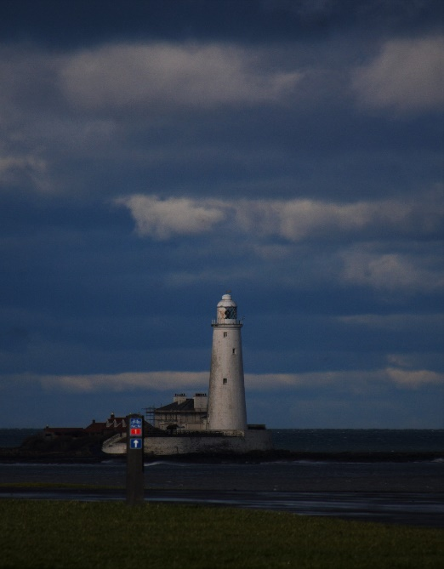
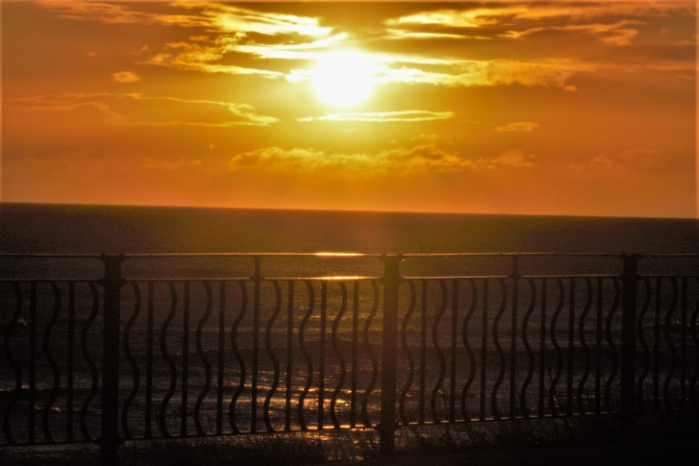
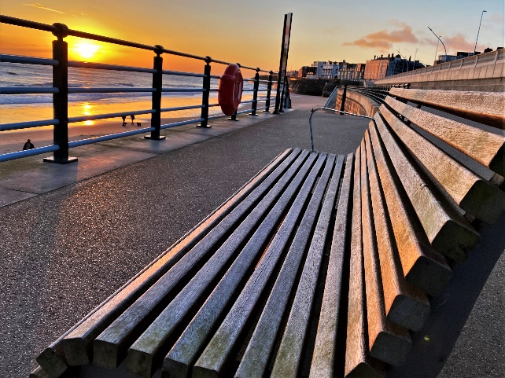
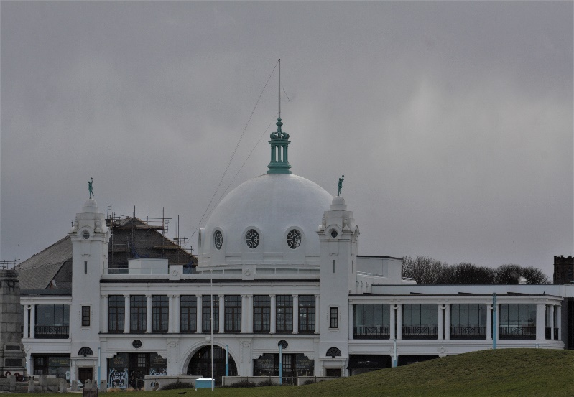
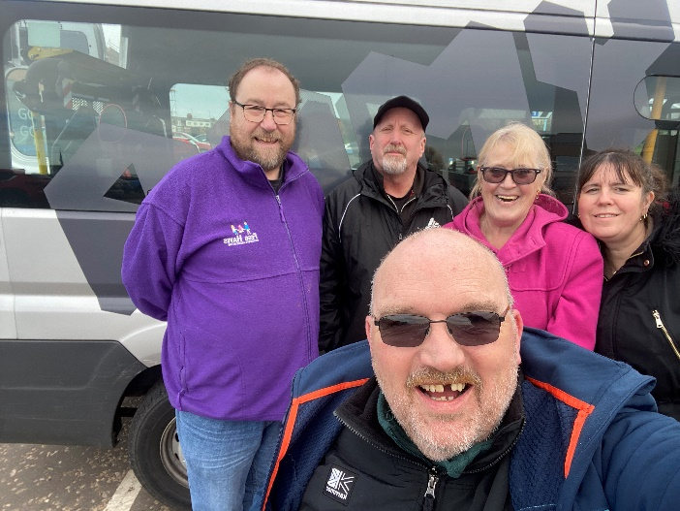
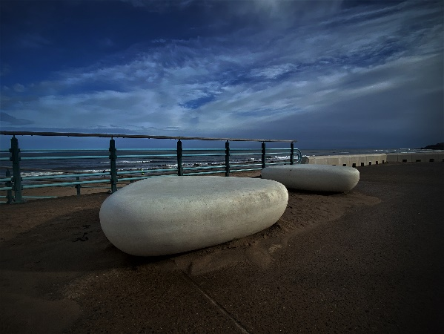
Pebble seat on Front
St Marys Light house
Spanish City

On way back home

